**Chapter 2:** The effects of climate, oceanography, and habitat on the distribution and abundance of northern California Current continental shelf groundfishes

**Abstract**

The California Current Ecosystem has been subject to a changing climate for many decades, leading to shifts in community structure and species distributions. In the northeastern Pacific, novel climate regimes have been detected and anomalous events like hypoxia and marine heatwaves have been observed on the continental shelf. These changes have the potential to impact marine species like groundfishes and therefore their associated fisheries. Using data collected by the NOAA surveys, this study uses statistical modeling to examine what environmental factors impact the shelf (≤ 200 m) groundfish populations and assemblages found on the continental shelf. We found that physical shelf structure drives the distribution of specific groundfish assemblages, with a separation between habitat types and depth zones. Individual species had strong depth preferences grouped in either shallow, midshelf, or deep clusters, which demonstrates the importance of physical habitat on groundfish assemblage composition. The large-scale climate indices tested were not significantly correlated with either species abundance or groundfish assemblages, while temperature and depth were correlated with abundance for most groundfish populations. Portions of the shelf that have experienced anomalous hypoxic events over the last two decades exhibit reductions in predicted probability of presence of hypoxia-intolerant species, while shallow-water species that tolerate warmer water as well as low dissolved oxygen concentrations exhibit shoreward compressed distributions. It is clear from the results of this study that there have been spatiotemporal changes in the shelf groundfish populations and assemblages, and that temperature is influential on an individual species basis.

**1 Introduction**

The U.S. West Coast continental shelf provides resources for coastal communities and habitat for the numerous species targeted by the non-whiting groundfish bottom trawl fleet. The fishery is a multispecies industry that has existed in some form since the beginning of the 20th century. It provides a significant amount of revenue for the U.S. West Coast states. In 2016, the fishery landed approximately 25,000 metric tons valued at a little over $30 million in ex-vessel revenue (Warlick et al., 2018). However, the majority of fishable groundfish stocks are currently underutilized, particularly in the wake of the recovery of the fishery during the last two decades and the majority of permit holders are located in the northern California Current region (Gorman & Fergus, 2000; Warlick et al., 2018). Following dramatic changes in West Coast groundfish management and policy over the last two decades, some regulations have been relaxed or removed. This may now create incentives to fish inner shelf habitats, which are not as heavily targeted.

The continental shelf in the northern California Current is the area inshore of the 200-meter isobath, which approximately demarcates the shelf-slope break, and the shelf extends anywhere from 17 km to almost 75 km offshore. The fishery in this area has been referred to as the “beach fleet” or the nearshore trawl fishery (Hannah et al., 2007; Sjostrom et al., 2020). Many of the shelf species live their entire lives on the shelf, including many of the flatfishes (Family *Pleuronectidae*) that dominate the sandy sedimentary habitat common to this region. Others migrate between slope and shelf habitat seasonally or occupy rocky habitat near the shelf-slope break (Day & Pearcy, 1968; Vetter & Lynn, 1997). Beginning in January 2020, the trawl Rockfish Conservation Area (RCA) that had restricted bottom-contact fishing in critical rockfish (*Sebastes* spp.) habitat along the shelf break since 2002 was removed from waters off Oregon and California (50 C.F.R. § 660.60 2019). The RCA removal allows vessels using bottom-contact gear to access species found on the outer shelf. With the imminent possibility of increased fishing pressure by Oregon and California fishermen on the continental shelf, it is necessary to provide a baseline of abundance, distribution, and their changes over time for shelf groundfishes. Portions of the continental shelf are understudied compared to the slope and this research aims to fill a gap in knowledge about shelf groundfishes. Using NOAA Alaska Fisheries Science Center (AFSC) and Northwest Fisheries Science Center (NWFSC) survey data, in this study we assess (1) how groundfish assemblage composition of the continental shelf has changed over time and what environmental factors or large scale climate patterns drive those changes, as well as (2) which groundfish species dominate the shelf habitat, how their distributions have shifted over time, and what environmental factors drive their spatial presence and abundance. Evaluating the northern California Current shelf groundfishes and the environmental variables that influence these species adds information that is lacking for future U.S. West Coast groundfish management under federal and state jurisdictions.

In the last four decades, the northeastern Pacific has experienced novel climate regimes and changes in regional oceanographic conditions (Hare & Mantua, 2000; Di Lorenzo et al., 2010; McClatchie et al., 2016; Harvey et al., 2019). Many fishes are sensitive to changes in oceanographic conditions (Hare & Mantua, 2000; Litzow, 2006; Szuwalski & Punt, 2013; Litzow & Mueter, 2014). Fluctuations in oceanic and atmospheric forcing lead to changes in regional chemical and physical oceanographic conditions such as temperature, salinity, upwelling, and dissolved oxygen (DO) (Hare & Mantua, 2000; Peterson & Schwing, 2003; Pierce et al., 2012; Di Lorenzo et al., 2013; Jacox et al., 2014; Litzow & Mueter, 2014). In the Gulf of Alaska and Bering Sea, multiple fish species respond to these changes, including groundfish populations (Szuwalski & Punt, 2013; Litzow et al., 2018; Puerta et al., 2019). In the North Pacific and other regions, several regime shifts have been described but they are notoriously difficult to predict and lead to a great deal of uncertainty for managers (Scheffer et al., 2001; Carpenter & Brock, 2006; deYoung et al., 2008).

In addition to decadal scale community restructuring, fish populations respond to environmental change on a seasonal and interannual basis and move to different habitats to spawn or feed each year (Cushing & Dickson, 1976; Levin et al., 1994; Ottersen et al., 2004, 2010; Maxwell et al., 2015). Two marine heatwaves and multiple anomalous hypoxia events have affected groundfishes targeted by commercial fishermen, signaling new challenges and more uncertainty for marine resource managers (Chan et al., 2008; Keller et al., 2010; Joh & Di Lorenzo, 2016; Gentemann et al., 2017; Sobocinski et al., 2018; Harvey et al., 2019; Amaya et al., 2020). Research on the effects of environmental variability on West Coast groundfishes has primarily been focused on individual species responses, rather than assemblages (Keller et al., 2010, 2015; Thorson et al., 2016; Tolimieri et al., 2018; Haltuch et al., 2019), though there are some examples (Tolimieri & Levin, 2006). NMFS survey temperature data indicates that the southern, narrow portion of the Oregon shelf experiences the warmest bottom water temperatures while the coldest are near Washington state. However, in the 1990s there was a transition to warm waters across the inner shelf (Fig. 1). DO levels and hypoxia became a significant focus of research following an anomalous hypoxic event in 2002 off the Oregon Coast (Grantham et al., 2004). A few shelf species have evolved physiological or behavioral adaptations to respond to hypoxia while most others have not, as they historically did not experience frequent hypoxic events (Keller et al., 2010, 2015, 2017a).

These were soon followed in 1977 by development of a NOAA AFSC-led triennial survey on the continental shelf with a transect sample design (referred to hereafter as the triennial survey), as well an annual slope survey beginning in 1984 (Keller et al., 2017b). In 2003, the NOAA NWFSC implemented an annual shelf and slope survey conducted using a randomly sampled grid (referred to hereafter as the annual survey), replacing the former AFSC surveys (Fig. 2). Although fishing by the remaining vessels continued to some degree on the shelf, the fishery offshore has drawn more scientific attention than the shallow shelf. Therefore, much of the focus on West Coast groundfish research has been aimed toward the offshore slope-dwelling groundfishes, especially Pacific whiting (hake) (*Merluccius productus*).

While individual species analyses are useful, understanding species interactions and co-occurrence is crucial for fishery management. In one of the first attempts to identify groundfish assemblages off the U.S. West Coast, Jay (1996) identified over fifteen common shelf clusters in the AFSC triennial survey data. Some of the dominant indicator species for these assemblages, as determined by abundance, included Dover sole (*Microstomus pacificus*), Pacific whiting, rex sole (*Glyptocephalus zachirus*), sablefish (*Anoplopoma fimbria*), arrowtooth flounder (*Atheresthes stomias*), shortspine thornyhead (*Sebastolobus alascanus*), darkblotched rockfish (*Sebastes crameri*), English sole (*Parophrys vetulus*), Pacific sanddab (*Citharichthys sordidus*), and spiny dogfish (*Squalus suckleyi*) (Jay, 1996). Both Weinberg (1994) and Williams and Ralston (2002) used the triennial survey to identify rockfish assemblages, though Williams and Ralston only looked at part of the northern California Current Ecosystem. Shelf rockfish assemblages identified in these studies had distributions centered at 150 m depth and included canary (*S. pinniger*), yellowtail (*S. flavidus*), widow (*S. entomelas*), sharpchin (*S. zacentrus*), rosethorn (*S. helvomaculatus*), yelloweye (*S. ruberrimus*), greenstriped (*S. elongatus*) and redstripe (*S. proriger*) rockfishes (Weinberg, 1994; Williams & Ralston, 2002).

The two survey datasets are not often used together due to differences in sampling methods, gear, and vessel type. Only one study has used both versions of the NOAA surveys to identify assemblages. Cope and Haltuch (2012) compared the two surveys in the context of assemblage presence and found that both surveys consistently included three groups. These were (1) a Dover-whiting-rex-slender sole (*Lyopsetta exilis*) core complex that also included arrowtooth flounder, spotted ratfish (*Hydrolagus colliei*), sablefish, spiny dogfish, longnose skate (*Raja rhina*), and sandpaper skate (*Bathyraja kincaidii*); (2) an English sole-Pacific sanddab complex that included petrale sole (*Eopsetta jordani*), lingcod (*Ophiodon elongatus*), spiny dogfish, and spotted ratfish; and (3) a chilipepper (*S. goodei*)-shortbelly (*S. jordani*) rockfish complex that included stripetail (*S. saxicola*), bocaccio (*S. paucispinis*), and greenstriped rockfishes (Cope & Haltuch, 2012). Identification of assemblages can help with bycatch management and is especially useful if the groupings persist temporally.

The continental shelf and slope serve as habitat for many flatfish species throughout varying life stages, including species that occupy the infrequently studied area inshore of 55 m depth that is not covered by the surveys. Many of the flatfishes targeted by the groundfish fishery, both in the past and present day, use the shelf for spawning or juvenile development. A number use both the slope and shelf habitat, conducting annual migrations from the shelf in the summer months to the deeper, cold slope waters to spawn in the fall and winter. This is the case for both Dover sole and petrale sole, though as Dover sole age they spend less time on the shelf (Pearcy et al., 1977; Hunter et al., 1990; Jacobson & Hunter, 1993; Love, 1996). The nursery grounds for these deep-spawning species vary, with juvenile rex sole typically found near the shelf/slope break while petrale sole and Dover sole recruits can be found on shallower portions of the shelf (Ketchen & Forrester, 1966; Pearcy et al., 1977; Markle et al., 1992). Other flatfishes spend their entire lives on the shelf and juveniles utilize estuaries for development. English sole, starry flounder (*Platichthys stellatus*), rock sole (*Lepidopsetta bilineata*), and speckled sanddab (*Citharichthys stigmaeus*) are all known to spawn on the continental shelf with their offspring recruiting to estuarine habitat (Krygier & Pearcy, 1986; Rackowski & Pikitch, 1989; Love, 1996; Schwartzkopf et al., 2020).

Roundfishes and rockfishes also use the shelf for spawning, breeding, and juvenile development. Juvenile sablefish are found on the shelf, and estuaries are known to be critical habitat for multiple life stages of lingcod and cabezon (Love, 1996; Schirripa & Colbert, 2006). Many species of skates (family *Rajidae*) occupy the soft sediment of the continental shelf and several are thought to spawn year-round in this region (Ebert, 2003; Bizzarro et al., 2014). Although adult commercially important rockfishes are not as abundant on the inner shelf as they are on the outer shelf and slope, many use shelf habitats like kelp forests or cobble beds as nursery habitat whereas others use estuarine habitats (Schwartzkopf et al., 2020). These rockfishes include species such as widow, yellowtail, bocaccio, and canary rockfishes, which have been consistently targeted off the U.S. West Coast, and were declared overfished at the collapse of the fishery (Love, 2011; Schwartzkopf et al., 2020). It is evident that the continental shelf is critical for a wide range of groundfish species, many of which are commercially important and use the shelf habitat to complete their life cycles.

**2 Data and Methods**

**2.1 NOAA West Coast Groundfish Bottom Trawl Surveys**

Survey data from both the triennial (1977 – 2001) and annual (2003 – 2018) version of NOAA groundfish surveys (Fig. 2) were used. For the triennial survey, Alaskan class trawl vessels equipped with a Poly Nor’Eastern trawl were used to sample transects running perpendicular to the coast. Sampling depth, transect spacing, and timing of the survey were variable, but tow time was consistent at 30 minutes. In 1980 the minimum depth was set to 55 m, changed from a minimum of 91 m in 1977. Up until 1995, sampling occurred from July to September or October; after 1995, sampling began in June and ended in August. The NWFSC annual survey began in 2003, combining the slope and shelf surveys operated by the AFSC. It uses four paired West Coast class trawlers equipped with an Aberdeen trawl and stations are selected using a stratified random sampling of cells placed along the U.S. West Coast shelf and slope. The first pass for the survey occurs from May to August and the second pass occurs from August to October with a tow time of 15 minutes. Both the triennial and annual surveys cover the region trawled by the commercial groundfish fishery, but the sampling density is greater for the annual survey. Due to differences in sampling methods for each survey, abundances cannot be compared across surveys; however, assessments of distribution based on presence/absence have proven useful (Thorson et al., 2016).

Data from the NOAA surveys was obtained from the NWFSC/FRAM Data Warehouse (url: https://www.nwfsc.noaa.gov/data/) as a dataset with characteristics from each tow and

a dataset with species composition information. Tow ID numbers were used to match tows to the species composition data and all surveys other than the annual and triennial surveys were

Table 1: Number of hauls containing each species were summed for each survey to determine occurrence. Only species that occurred in over 1% of hauls are listed below. Depth and temperature ranges were calculated using both survey datasets. Bolded species were selected for individual analyses.

|  |  |  |  |  |  |  |  |  |
| --- | --- | --- | --- | --- | --- | --- | --- | --- |
|  |  | No. of Hauls | | | % Occurrence | |  |  |
| Common Name | Scientific Name | NWFSC | AFSC | NWFSC | | AFSC | Depth (m) | Temp. (°C) |
| Rex sole | ***Glyptocephalus zachirus*** | **2327** | **1778** | **97%** | | **92%** | **78 - 438** | **5.8 - 8.1** |
| Dover sole | ***Microstomus pacificus*** | **2258** | **1687** | **94%** | | **87%** | **82 - 711** | **5.7 - 8.1** |
| Petrale sole | ***Eopsetta jordani*** | **2219** | **1206** | **92%** | | **62%** | **72 - 192** | **6.7 - 8.3** |
| Spotted ratfish | *Hydrolagus colliei* | 1963 | 853 | 82% | | 44% | 78 - 307 | 6.3 - 8.1 |
| English sole | ***Parophrys vetulus*** | **1902** | **1245** | **79%** | | **64%** | **70 - 201** | **6.7 - 8.3** |
| Arrowtooth flounder | ***Atheresthes stomas*** | **1883** | **1269** | **78%** | | **65%** | **90 - 406** | **5.9 - 8.1** |
| Longnose skate | *Raja rhina* | 1862 | 518 | 77% | | 27% | 91 - 459 | 5.7 - 8.1 |
| Lingcod | ***Ophiodon elongatus*** | **1596** | **892** | **66%** | | **46%** | **77 - 213** | **6.7 - 8.3** |
| Pacific sanddab | ***Citharichthys sordidus*** | **1536** | **1149** | **64%** | | **59%** | **68 - 137** | **7.0 - 8.5** |
| Greenstriped rockfish | *Sebastes elongatus* | 1296 | 910 | 54% | | 47% | 108 - 215 | 6.6 - 8.1 |
| Sablefish | ***Anoplopoma fimbria*** | **1236** | **1247** | **51%** | | **64%** | **107 - 957** | **5.5 - 8.0** |
| Big skate | *Beringraja binoculata* | 1086 | 174 | 45% | | 9% | 68 - 169 | 6.8 - 8.5 |
| Sandpaper skate | *Bathyraja kincaidii* | 1002 | 193 | 42% | | 10% | 108 - 447 | 5.6 - 7.7 |
| Spiny dogfish | *Squalus suckleyi* | 985 | 1087 | 41% | | 56% | 79 - 311 | 6.4 - 8.2 |
| Darkblotched rockfish | *Sebastes crameri* | 791 | 787 | 33% | | 41% | 120 - 357 | 6.1 - 7.9 |
| Flathead sole | *Hippoglossoides elassodon* | 693 | 493 | 29% | | 25% | 98 - 183 | 6.6 - 7.8 |
| Yellowtail rockfish | *Sebastes flavidus* | 549 | 629 | 23% | | 32% | 98 - 188 | 6.7 - 7.8 |
| Canary rockfish | *Sebastes pinniger* | 548 | 589 | 23% | | 30% | 79 - 195 | 6.7 - 8.2 |
| Stripetail rockfish | *Sebastes saxicola* | 504 | 246 | 21% | | 13% | 120 - 230 | 6.6 - 8.3 |
| Pacific cod | *Gadus macrocephalus* | 330 | 269 | 14% | | 14% | 74 -194 | 6.7 - 7.8 |
| Rosethorn rockfish | *Sebastes helvomaculatus* | 314 | 199 | 13% | | 10% | 65 - 107 | 6.0 - 7.8 |
| Curlfin sole | *Pleuronichthys decurrens* | 276 | 79 | 11% | | 4% | 62 - 94 | 7.1 - 8.6 |
| Splitnose rockfish | *Sebastes diploproa* | 270 | 211 | 11% | | 11% | 160 - 381 | 5.9 - 7.7 |
| Sharpchin rockfish | *Sebastes zacentrus* | 253 | 219 | 11% | | 11% | 144 - 299 | 6.3 - 7.9 |
| Rock sole | *Lepidopsetta bilineata* | 247 | 51 | 10% | | 3% | 64 - 112 | 7.0 - 8.1 |
| Shortspine thornyhead | *Sebastolobus alascanus* | 212 | 371 | 9% | | 19% | 196 - 1020 | 5.3 - 7.5 |
| Pacific Ocean perch | *Sebastes alutus* | 184 | 182 | 8% | | 9% | 160 - 402 | 5.8 - 7.6 |
| Butter sole | *Isopsetta isolepis* | 162 | 27 | 7% | | 1% | 61 - 83 | 7.1 - 8.7 |
| Redbanded rockfish | *Sebastes babcocki* | 166 | 122 | 7% | | 6% | 170 - 372 | 5.9 - 7.5 |
| Yelloweye rockfish | *Sebastes ruberrimus* | 159 | 109 | 7% | | 6% | 92 - 199 | 6.7 - 8.1 |
| Kelp greenling | *Hexagrammos decagrammus* | 145 | 46 | 6% | | 2% | 69 - 122 | 7.1 - 8.7 |
| Chilipepper | *Sebastes goodei* | 152 | 30 | 6% | | 2% | 120 - 235 | 6.7 - 8.8 |
| Blackspotted/Rougheye | *Sebastes aleutian. / melanost.* | 141 | 190 | 6% | | 10% | 139 - 425 | 5.6 - 7.5 |
| Sand sole | *Psettichthys melanostictus* | 113 | 64 | 5% | | 3% | 60 - 79 | 7.3 - 8.6 |
| Greenspotted rockfish | *Sebastes chlorostictus* | 121 | 28 | 5% | | 1% | 99 - 175 | 7.0 - 8.2 |
| Widow rockfish | *Sebastes entomelas* | 131 | 160 | 5% | | 8% | 131 - 312 | 6.2 - 7.9 |
| Shortbelly rockfish | *Sebastes jordani* | 109 | 124 | 5% | | 6% | 115 - 234 | 6.7 - 8.4 |
| Redstripe rockfish | *Sebastes proriger* | 126 | 156 | 5% | | 8% | 100 - 221 | 6.6 - 8.0 |
| California skate | *Raja inornata* | 73 | 2 | 3% | | - | 67 - 103 | 7.4 - 9.2 |
| Starry skate | *Raja stellulata* | 84 | 6 | 3% | | 30% | 70 - 157 | 6.9 - 8.6 |
| Pygmy rockfish | *Sebastes wilsoni* | 83 | 89 | 3% | | 5% | 97 - 180 | 6.8 - 8.1 |
| Starry flounder | *Platichthys stellatus* | 44 | 18 | 2% | | - | 62 - 78 | 7.2 - 8.6 |
| Silvergray rockfish | *Sebastes brevispinis* | 45 | 83 | 2% | | 4% | 95 - 255 | 6.3 - 7.7 |
| Quillback rockfish | *Sebastes maliger* | 45 | 18 | 2% | | - | 65 - 107 | 7.1 - 8.1 |
| Bocaccio | *Sebastes paucispinis* | 53 | 137 | 2% | | 7% | 103 - 229 | 6.8 - 8.5 |
| Black rockfish | *Sebastes melanops* | 6 | 27 | - | | 1% | 60 - 79 | 7.1 - 8.6 |

removed. To include only data on the continental shelf, data collected at 200 m depth, approximately the shelf/slope break, or shallower was retained. Logbook data that tracks activity of commercial groundfish fishermen was used to set latitude bounds of 41°N and 48°N in order to include only waters they consistently fish. Pacific whiting and species not managed by the Pacific Fishery Management Council (PFMC) as part of the Groundfish Fishery Management Plan, along with invertebrates, were removed. Of those species remaining, only those present in over 1% of all tows were kept. This was done for each survey individually, resulting in 47 and 44 species retained for the annual and triennial surveys, respectively (Table 1).

**2.2 Environmental Data**

Covariates tested include bottom temperature, depth, day of year, the Pacific Decadal Oscillation (PDO) monthly index, and the North Pacific Gyre Oscillation (NPGO) monthly index. Bottom temperature and depth were recorded during both the annual and triennial surveys. For the triennial survey, depth and temperature were measured by a bathythermograph attached to the headrope. For the annual survey, net performance and position were recorded by Simrad Integrated Trawl Instrumentation and P144 Catch Monitoring Systems while temperature was measured by a SeaBird SBE 39 recorder on the wing. Depth was measured by a depth sensor on the headrope, with a final value recorded as sum of trawl headrope depth and distance from seafloor. Day of the year was used to assess seasonal shifts. PDO monthly values were retrieved from the University of Washington Cooperative Institute for Climate, Ocean, and Ecosystem Studies (url: http://research.jisao.washington.edu/pdo/PDO.latest) and matched to the trawl characteristic dataset using month and year. A similar method was used for the NPGO, with monthly values retrieved from the North Pacific Gyre Oscillation webpage (url: http://www.o3d.org/npgo/).

**2.3 Data Analysis**

To assess both assemblages and individual species, both multivariate and univariate statistical methodologies were used. All analyses were performed using the R programming language (R Core Team, 2019). Eight species were selected for individual analyses: sablefish, Pacific sanddab, petrale sole, Dover sole, English sole, arrowtooth flounder, rex sole, and lingcod. These eight were selected because they were consistently caught throughout the entire survey time series, have either current or historic commercial importance, and live predominantly on the shelf during the months surveyed. Petrale sole and lingcod were the only species selected that were classified as overfished by the PFMC, which occurred in 1999 and 2009 respectively, and the stocks were considered rebuilt in 2005 for lingcod and 2014 for petrale sole (Haltuch et al., 2018; Wetzel, 2019). Flatfishes were the primary species selected due to their prevalence on the shelf and because they make up the majority of catches in the nearshore groundfish fishery (Sjostrom, 2019).

Non-metric multidimensional scaling (NMS) was chosen to look at assemblage structure and environmental drivers of community composition on the shelf. Initial exploratory analyses were conducted to determine any appropriate data adjustments, which resulted in a log(x+1) transformation. NMS was chosen due to its utility with data that does not exhibit linear relationships between variables and is zero-inflated, both of which are characteristic of the survey data (McCune & Grace, 2002; Keller et al., 2017b). To perform NMS, a Bray-Curtis (Sørensen) dissimilarity matrix was created using species matrices for each survey where trawls were rows and species were columns. Stress, the difference in distance between the reduced ordination space and the original dissimilarity matrix, was minimized for the species matrices to the lowest possible value until a final, low-stress matrix was achieved. The final ordination plots show similar points clustered together while points or clusters that are different are further away from other points and clusters. Bray-Curtis distances were chosen because of their relative insensitivity to outliers and ability to deal with large variation in species abundance (Clarke, 1993; McCune & Grace, 2002). Each axis of the ordination is orthogonal and explains patterns in the resulting plot of sample units. Ties were not penalized in this analysis, as they were infrequent (< 1%).

Initial exploratory NMS ordinations for both surveys used groundfish species with a frequency of occurrence over 1% and an environmental matrix of the climate and oceanographic variables. Both species richness and the Shannon-Wiener diversity index were calculated once the final ordination for each survey was plotted to assess any gradients regarding those two metrics. Richness was calculated as the number of species in a given tow and the Shannon-Wiener index as $H^{'}= -\sum_{i}^{S}{p_{i}\ln\left(p_{i}\right)}$ (Hill, 1973). Analyses were performed using the vegan package in R (Oksanen et al., 2019). To assess any potential a-priori groupings in the NMS ordinations, two categories were created for both the PDO and NPGO to denote negative and positive phases. Years were also categorized for each sample, with 25 years total. To test whether there was a relationship between the groups and climate variables or year, a multiple response permutation procedure (MRPP) was used. This is a nonparametric procedure that calculates the chance-corrected within-group agreement and a corresponding p-value (McCune & Grace, 2002).

Generalized additive models (GAM) were used to assess spatiotemporal relationships between individual species and the marine environment. GAMs are regression models that incorporate smooth terms and can capture nonlinear relationships. Non-stationary GAMs, known as threshold GAMs (TGAM), exhibit two or more eras during which the functional relationships between species’ population and smoothed terms can change (Ciannelli et al., 2004). Both stationary GAM and TGAM formulations incorporating regional oceanographic and climate covariates were tested for each species. TGAMs were used to assess spatial shifts before and after a threshold year in order to determine if there was movement of species and if this movement occurred at a certain point in time. TGAMs created for each species contained data for the duration of the survey, including both the triennial survey and the annual survey data from 1977 to 2018, and focused on presence/absence. The stationary model formulation used for comparison with the TGAM is as follows:

(Eq. 1) ${l(μ)}_{y,lat,lon}= α_{y}+ s_{1}\left(J_{y,lat,lon}\right)+s_{2}\left({lat}_{y}, {lon}_{y}\right)$

where *l* is a link function (*logit* for presence/absence data), and $μ$ indicates the probability of presence for each species at station. Latitude and longitude $(lat, lon)$, year $(y)$, and day of the year $\left(J\right)$ are smooth functions $(s)$ for each covariate. Presence/absence data follow the Bernoulli distribution, with mean equal to $μ$ and variance equal to $μ$ (1- $μ$). This stationary formulation was then compared to the TGAM:

(Eq. 2) ${l(μ)}_{y,lat,lon}= α_{y}+ s_{1}\left(J_{y,lat,lon}\right)+\left\{\begin{aligned} s_{2}\left({lat}_{y}, {lon}_{y}\right), if y<t \\ s_{3}\left({lat}_{y}, {lon}_{y}\right), if y≥t\end{aligned}\right.$

The TGAM formulations use a threshold year $(t)$ to separate different periods of time. The TGAM tests all possible threshold years between the upper and lower quantiles of data in the combined survey dataset (1986 to 2015) for all species by minimizing Akaike’s Information Criteria (AIC). The regions with significant change in spatial distribution were identified by computing the difference in predicted probability of presence plus or minus the 90% confidence intervals before and after the threshold year. Significant changes in the predicted probability of presence were those that did not include the zero value. For the two species with high frequency of occurrence throughout both surveys (see Table 1, Dover sole and rex sole), the year factor was removed because models fit with year resulted in predictions that greatly deviated from the observations, likely due to model overfitting when the majority of the observations were presence. The ΔAIC between the stationary GAM formulation and TGAM was calculated and TGAM was selected for a given species if ΔAIC was positive. To validate the TGAM results, the predicted probability of presence before the threshold was subtracted from the predicted probability of presence after the threshold for each species and the resulting confidence interval was calculated to determine areas of significant increase or decrease in predicted probability of presence. Then, for corresponding areas, observed change in presence for each species was calculated and compared to the model predicted change.

Stationary GAMs using CPUE or presence/absence as the response variable were fitted for each of the eight species to determine relationships between individual species and environmental or climatic variability (Table A.1). For the presence/absence models, the same formulation in Equation 1 was used and a comparison was made between the model with day of the year and without. CPUE models using bottom temperature as recorded by the surveys were formulated as follows:

(Eq. 3) $CPUE_{y,lat,lon}= s_{1}\left(y\right)+s_{2}\left(lat_{y},lon_{y}\right)+s_{3}\left(J_{y,lat,lon}\right)+s_{4}\left(D_{lat,lon}\right)+s_{5}\left(T_{y,lat,lon}\right)+ ε_{y,lat,lon}$

The same explanatory variables used in the TGAM formulations were used here with the addition of year $(y)$, depth $(D)$, and bottom temperature ( $T)$ as smooth terms. For the climate indices (PDO and NPGO) the GAM formulation was as follows, with year replaced by the climate index $(C)$:

(Eq. 4) $CPUE_{y,lat,lon}= s_{1}\left(C\right)+s_{2}\left(lat_{y},lon_{y}\right)+s_{3}\left(J_{y,lat,lon}\right)+s_{4}\left(D_{lat,lon}\right)+s_{5}\left(T_{y,lat,lon}\right)+ ε_{y,lat,lon}$

The full models containing each environmental or climate covariate was compared to a null model with the covariate removed. The model with the lowest AIC was selected as the best model. To validate the TGAM results, the predicted probability of presence before the threshold was subtracted from the predicted probability of presence after the threshold for each species and the resulting confidence interval was calculated to determine areas of significant increase or decrease in predicted probability of presence. Then for corresponding areas, observed change in presence for each species was calculated and compared to the model predicted change.

**3 Results**

Frequency of occurrence for each species was variable between the triennial and annual surveys. In general, occurrence was lower for flatfish during the triennial survey and many rockfishes were caught less frequently during the annual survey. All skates except the starry skate were caught more often by the annual survey than the triennial survey and there was a larger change in frequency of occurrence between surveys for skates than the other groups. Occurrence for roundfish and other miscellaneous species was variable.

The final annual and triennial survey ordinations were two-dimensional with a stress of 0.17 and 0.18, respectively (Fig. 3). A two-dimensional ordination was chosen due to a reduction in stress at two dimensions. Depth was the only environmental gradient strongly related to either ordination. Other gradients assessed were latitude, day of the year, the climate indices, year, and temperature and an r2 < 0.2 was used as a cutoff when determining gradient strength (McCune & Grace, 2002). In both final ordinations, a depth gradient was primarily represented by axis 1 and while not explicitly quantified for this analysis, axis 2 seemed linked to habitat types. Flatfishes were grouped together on axis 2 for both ordination plots, indicating their association with the inshore sedimentary habitat, while the rockfishes were dispersed along the entire axis illustrating a diversity in habitat preference. In the annual survey ordination, species diversity and richness increased along axis 1. For the triennial survey, species diversity and richness increased along axis 1 and decreased along axis 2. MRPP results for year, PDO, and NPGO indicated no likely relationship between any of those variables and species abundance for either survey, though year had slightly stronger relationship to abundance than did than either climate index (Table 2). When the two final survey ordinations were compared, it was evident that there was little change in assemblage structure in shallow and sandy habitat whereas in areas of the shelf deeper than 120 m, composition differed between the two (Fig. 3).

The distribution of some groundfish populations has significantly changed during the time frame considered, but the year of change (threshold) depends on the species. The earliest distributional changes were in 1995 for Dover sole and English sole and 1989 for Pacific

sanddab and rex sole. All other species had shifts that occurred during the annual survey (year ≥ 2003, Table 3). Petrale sole had the most recent change in 2011. For sablefish and petrale sole there were multiple years with locally minimum AIC values and when inspected, these secondary threshold years resulted in similar changes in distribution as those observed in the primary threshold year. For sablefish, although 2015 had the lowest AIC value, 2003 was chosen instead because it was not at the boundary of the upper quantile of data in the combined survey

Table 2: MRPP test results for the annual and triennial surveys. Categorical variables tested were year, PDO, and NPGO, all of which showed no relationship in visual assessment using the ordination plot. The A value indicates the amount of variance in each group, with A = 0 representing within-group randomization expected by chance and A = 1 representing within-group homogeneity. For community ecology an A > 0.3, for example, would mean there is substantially less randomization than expected by chance. The table shows there is little difference between positive and negative phase groupings for PDO and NPGO or between years.

|  |  |  |  |  |
| --- | --- | --- | --- | --- |
|  | Annual Survey | | Triennial Survey | |
| Variable | A value | p-value | A value | p-value |
| year | 0.017 | 0.001 | 0.055 | 0.001 |
| PDO | 0.0023 | 0.001 | 0.017 | 0.001 |
| NPGO | 0.0029 | 0.001 | 0.010 | 0.001 |

Table 3: TGAM results for eight groundfish species. Deviance explains the goodness of fit of the model. ΔAIC indicates the difference in AIC between the reference model and the model containing the threshold.

|  |  |  |  |
| --- | --- | --- | --- |
| Species | Threshold Year | Deviance | ΔAIC |
| Petrale Sole | 2011 | 28.5% | 53.9 |
| Lingcod | 2009 | 11.3% | 46.4 |
| Arrowtooth Flounder | 2007 | 36.5% | 27.0 |
| Sablefish | 2003 | 24.5% | 11.3 |
| English Sole | 1995 | 35.0% | 64.0 |
| Dover Sole | 1995 | 23.1% | 154.8 |
| Pacific Sanddab | 1989 | 57.4% | 73.0 |
| Rex Sole | 1989 | 19.9% | 49.9 |

dataset used for the TGAM analyses and distribution maps from both 2003 and 2015 indicated the same distributional pattern for sablefish. The petrale sole model had low AIC values in both 1998 and 2011, but the primary threshold year was retained (2011). The four species with early threshold years (Dover sole, rex sole, English sole, and Pacific sanddab) had steady increases in AIC values following their respective threshold years (Fig. 4).

All species except Dover sole had a predicted reduction in the predicted probability of presence after the threshold year on the continental shelf near Heceta and Stonewall Banks (Fig. 5). A reduction inshore was statistically significant for lingcod and Petrale sole while offshore reduction was significant for arrowtooth flounder, English sole, and Pacific sanddab (Table A.3). There was an observed decrease in presence inshore in the original data for rex sole and sablefish in the same region as lingcod and petrale sole, but these decreases were not statistically significant. Petrale sole distributional patterns were the most strikingly different before and after the threshold, with more predicted areas of catch located in shallow waters before 2011. After 2011 there are noticeable predicted decreases in the northern and central inshore areas of the shelf. Arrowtooth flounder, Dover sole, and lingcod had predicted reductions in presence off the coast of Washington while there were increases predicted for sablefish, English sole, rex sole, and Dover sole off southern Oregon/northern California. This southern increase was exclusively seen in species with early threshold years. Dover sole and rex sole both had general increases in predicted probability of presence, but this was only significant throughout the study region for Dover sole. It was additionally evident that the two inshore species, English sole and Pacific sanddab, have more compressed distributions following their respective threshold years. After 1995 it appeared that catches of English sole were compressed shoreward except in areas south of Charleston, OR. The Pacific sanddab population was predicted to be concentrated inshore of the 100-meter isobath.

Individual species distribution models for the eight species (Eq. 3) resulted in the inclusion of year for the final model for all species. In the annual survey final models, the temperature covariate was kept for the Pacific sanddab, lingcod, sablefish, arrowtooth flounder, rex sole, and Dover sole (Table 4). For the triennial survey, temperature was kept in models for five species: Pacific sanddab, sablefish, arrowtooth flounder, English sole, and rex sole. None of the climate indices were selected for any species or survey. Depth was a significant covariate for all models. For the annual survey GAMs that included temperature, Pacific sanddab, lingcod,

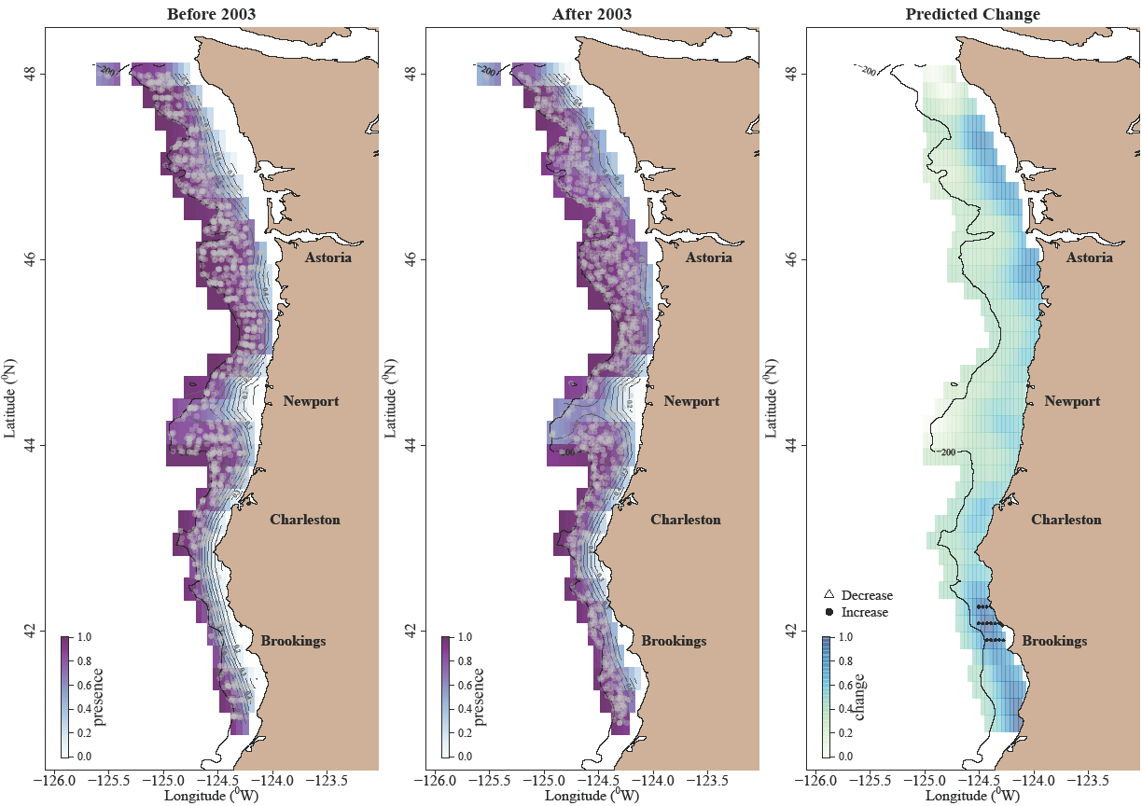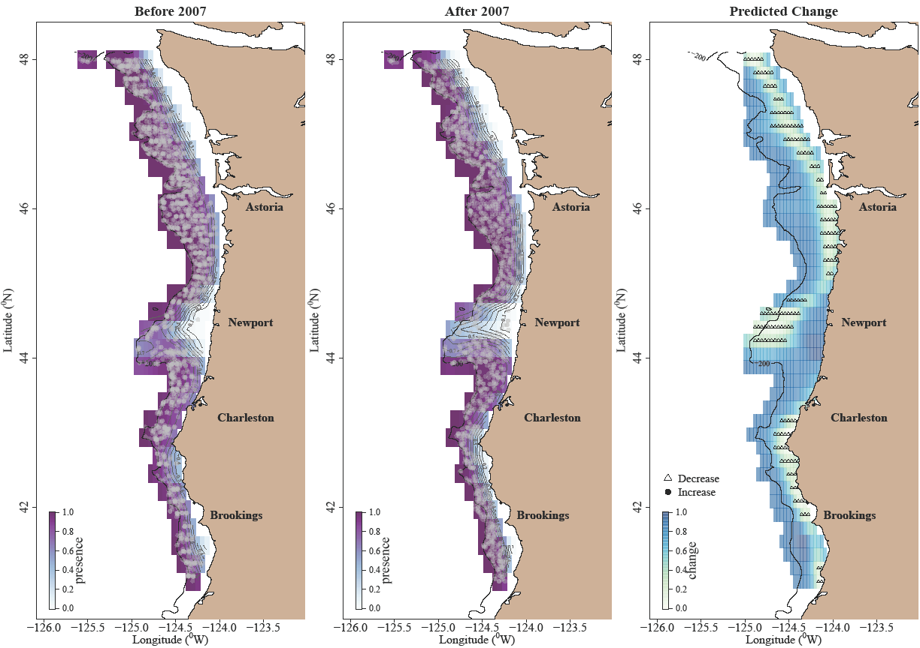

Figure 5: Model output for TGAMs. The left and middle panels display model predicted probability of presence prior to and after the selected threshold year overlaid with actual survey catch locations (gray circles). The right panel depicts differences in probability of presence before and after the threshold year and is overlaid with areas of statistically significant decrease or increase in probability of presence following the threshold year.

**Sablefish**

**Petrale Sole**

**Pacific Sanddab**

**English Sole**

Figure 5 continued.

**Rex Sole**

Figure 5 continued.

**Arrowtooth Flounder**

**Lingcod**

Figure 5 continued.

**Dover Sole**

Table 4: GAM formulations for individual species using the annual survey data. Deviance explains the goodness of fit of the model. ΔAIC indicates the difference in AIC between the reference model and the model containing the threshold.

|  |  |  |  |  |  |  |  |  |
| --- | --- | --- | --- | --- | --- | --- | --- | --- |
| Species | Best Model for Annual Survey | ΔAIC | | GCV | Deviance | | Adj. R2 | |
| Pacific Sanddab | $$CPUE_{y,lat,lon}= s_{1}\left(y\right)+s_{2}\left(lat_{y},lon_{y}\right)+s_{3}\left(J_{y,lat,lon}\right)+s_{4}\left(D_{lat,lon}\right)+s_{5}\left(T_{y,lat,lon}\right)+ ε_{y,lat,lon}$$ | 6.91 | 1.69 | | | 46.4% | | 0.45 | |
| English Sole | $$CPUE_{y,lat,lon}= s_{1}\left(y\right)+s_{2}\left(lat_{y},lon_{y}\right)+s_{3}\left(J_{y,lat,lon}\right)+s_{4}\left(D_{lat,lon}\right)+s_{5}\left(T_{y,lat,lon}\right)+ ε_{y,lat,lon}$$ | 1.48 | 1.45 | | | 31.2% | | 0.30 | |
| Lingcod | $$CPUE_{y,lat,lon}= s_{1}\left(y\right)+s_{2}\left(lat_{y},lon_{y}\right)+s_{3}\left(J_{y,lat,lon}\right)+s_{4}\left(D_{lat,lon}\right)+ ε_{y,lat,lon}$$ | 0.51 | 0.64 | | | 15.0% | | 0.13 | |
| Petrale Sole | $$CPUE_{y,lat,lon}= s_{1}\left(y\right)+s_{2}\left(lat_{y},lon_{y}\right)+s_{3}\left(J_{y,lat,lon}\right)+s_{4}\left(D_{lat,lon}\right)+ ε_{y,lat,lon}$$ | 1.96 | 0.84 | | | 22.9% | | 0.22 | |
| Arrowtooth Flounder | $$CPUE_{y,lat,lon}= s_{1}\left(y\right)+s_{2}\left(lat_{y},lon_{y}\right)+s_{3}\left(J_{y,lat,lon}\right)+s_{4}\left(D_{lat,lon}\right)+s_{5}\left(T_{y,lat,lon}\right)+ ε_{y,lat,lon}$$ | 7.38 | 0.80 | | | 43.6% | | 0.42 | |
| Dover Sole | $$CPUE_{y,lat,lon}= s_{1}\left(y\right)+s_{2}\left(lat_{y},lon_{y}\right)+s_{3}\left(J_{y,lat,lon}\right)+s_{4}\left(D_{lat,lon}\right)+ ε_{y,lat,lon}$$ | 4.57 | 0.90 | | | 55.1% | | 0.54 | |
| Rex Sole | $$CPUE_{y,lat,lon}= s_{1}\left(y\right)+s_{2}\left(lat_{y},lon_{y}\right)+s_{3}\left(J_{y,lat,lon}\right)+s_{4}\left(D_{lat,lon}\right)+s_{5}\left(T_{y,lat,lon}\right)+ ε_{y,lat,lon}$$ | 3.25 | 1.04 | | | 34.3% | | 0.33 | |
| Sablefish | $$CPUE_{y,lat,lon}= s_{1}\left(y\right)+s_{2}\left(lat_{y},lon_{y}\right)+s_{3}\left(J_{y,lat,lon}\right)+s_{4}\left(D_{lat,lon}\right)+ ε_{y,lat,lon}$$ | 0.58 | 0.82 | | | 15.4% | | 0.13 | |

and sablefish all showed some level of increase in abundance up to 9°C, and the opposite was true for rex sole (Fig. 6). Dover sole exhibited an almost linear decrease in abundance with increasing temperature, while arrowtooth flounder had a dip in abundance at about 7°C. For the triennial survey, English sole exhibited an increase in abundance up to about 8°C (Fig. A.1). Two species were best represented by models that included temperature but had weak relationships with temperature (Table A.2). These species were Pacific sanddab, which had slight peak in abundance at about 8°C, and rex sole, which exhibited an increase in abundance with increasing temperature. The arrowtooth flounder triennial survey model showed a similar relationship to the annual survey model results, with a dip in abundance at 8°C and a sharp increase up to 7°C. For the annual survey there was a clear trend of increasing abundance with increasing depth for arrowtooth flounder, rex sole, Dover sole, and sablefish (Fig. 7). Both English sole and lingcod showed trends of increasing in abundance with decreasing depth. Petrale sole had a peak in abundance at about 100 m depth while Pacific sanddab had steadily patterns in depth were similar for the triennial survey though there was a sharp peak in abundance for rex sole at about 180 m depth and petrale sole abundance steadily declined with high abundance up to about 120 m depth at which point abundance quickly decreased. These patterns in depth were similar for the triennial survey though there was a sharp peak in abundance for rex sole at about 180 m depth and petrale sole abundance steadily declined with increasing depth (Fig. A.2). In general, all species had strong relationships with depth, and inner to mid-shelf species had either a weak relationship with temperature or their abundance increased with increasing temperature, whereas deeper water species’ abundances increased with decreasing temperature.

**Pacific Sanddab**

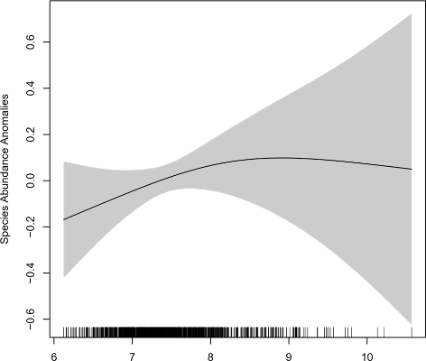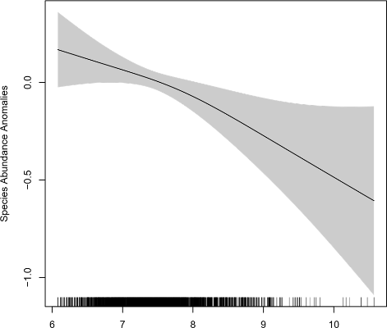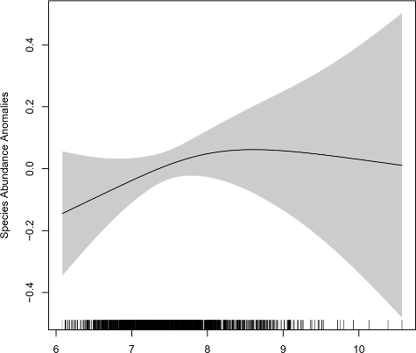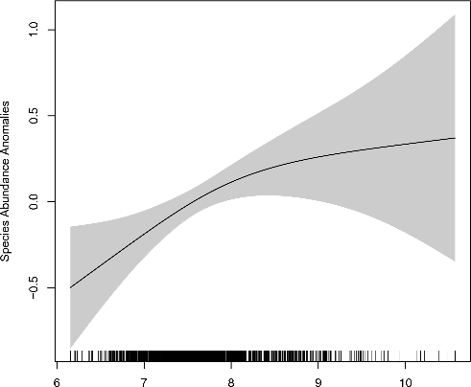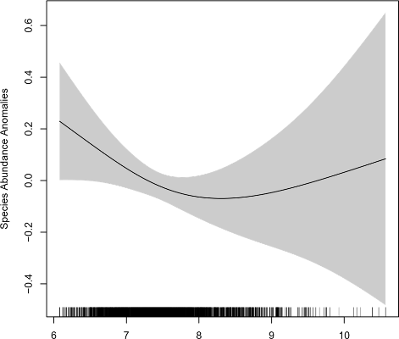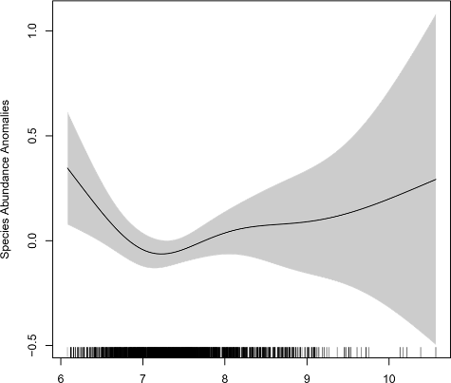

**Sablefish**

**Rex Sole**

**Lingcod**

**Dover Sole**

**Arrowtooth Flounder**

**Temperature (°C)**

**Species Abundance Anomalies**

Figure 6: Effect of temperature on six species for which temperature was included as a covariate in each selected stationary GAM formulation for the annual survey.

**4 Discussion**

**4.1 Changes in species catchability and presence in the surveys**

This study aimed to characterize shelf groundfishes and their relationships to the marine environment over the last four decades. There were differences between the annual and triennial survey data regarding frequency of occurrence of certain species. However, some of those differences may be due to differences in the survey design rather than actual changes in species surveys indicates higher catchability for skates with the current annual survey sampling configuration. Starry skate is the only skate species represented here that has an affinity for rocky occurrence. The change in frequency of skate occurrence between the triennial and annual habitat, so the species’ unique habitat preference, and therefore lower frequency of occurrence in the annual survey, may be a result of the change to a smaller footrope that cannot handle as rough of habitat (James et al., 2014; Bizzarro et al., 2014; Keller et al., 2017b). While the triennial survey footrope was better able to trawl over low relief rocky habitat, the tows were longer (30 minutes) than the annual survey (15 minutes), leading to a greater possibility of net hang-ups on high relief habitat. Therefore, the annual survey could access areas close to high relief areas of the seafloor which may lead to increased catch of species that live near this type of habitat.

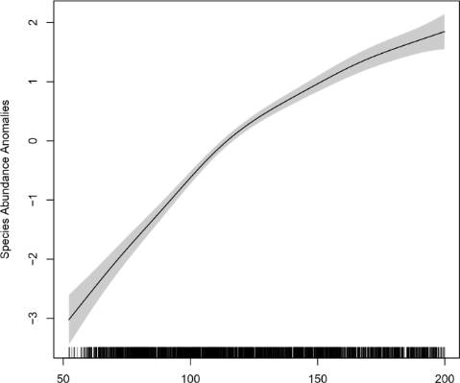

**Dover Sole**

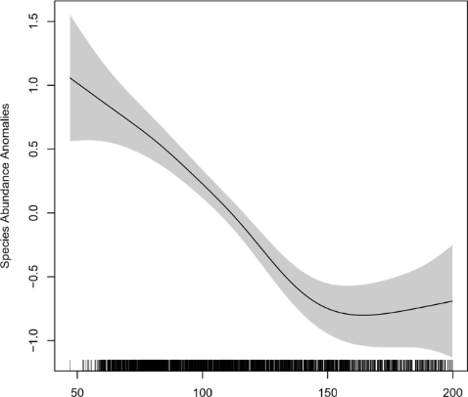

**English Sole**

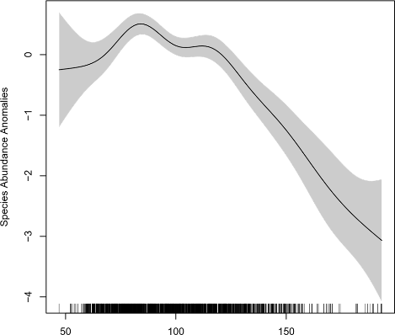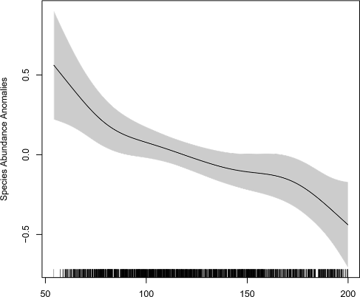

**Lingcod**

**Sablefish**

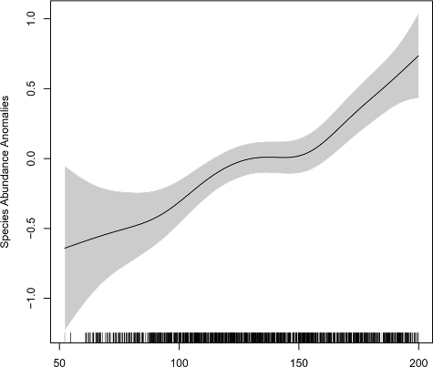

**Pacific Sanddab**

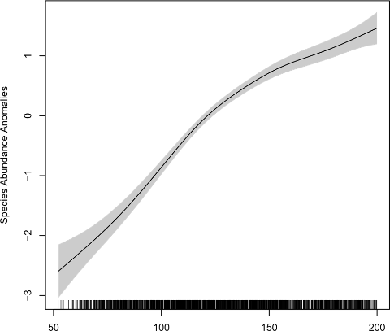

**Arrowtooth Flounder**

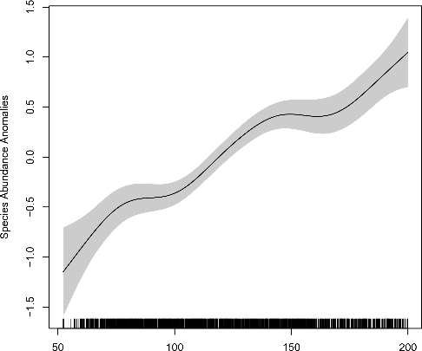

**Rex Sole**

**Depth (m)**

**Species Abundance Anomalies**

Figure 7: Effect of depth on eight species for each selected stationary GAM formulation for the annual survey.

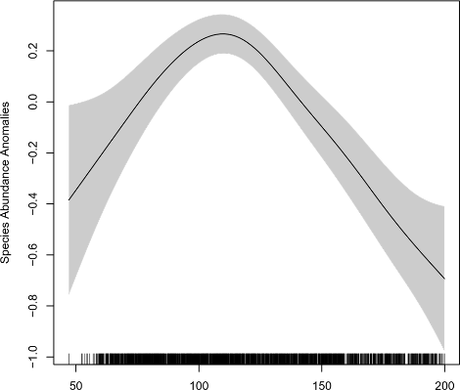

**Petrale Sole**

Changes over time of sample design may have led to the apparent TGAM threshold years in 1989 (rex sole and Pacific sanddab) and 1995 (Dover sole and English sole). The early years of the triennial survey were characterized by variability in transect distance and selection of depth bins, but the sampling design was standardized in 1995 (Keller et al., 2017b). The same explanation is possible for the sablefish model, with a threshold year of 2003 coinciding with the year the annual survey began.

4.2

The NMS and MRPP results indicated that depth has consistently been the primary influence on shelf groundfish assemblages, and the GAM output further illustrates individual species’ strong correlation with this covariate (Fig. 7, A.2). This is in congruence with recent work that found juvenile groundfish communities to be primarily depth structured, as well as with past multivariate analysis of survey data came (Williams & Ralston, 2002; Sobocinski et al., 2018; Haven, 2019). In addition to depth, there is also likely a relationship between assemblage species composition and habitat. Much of the shelf habitat is sand, silty mud, or a mixture of the two sediment types but there are several rocky banks offshore (Kulm et al., 1975; Romsos et al., 2007). Thus, the shelf flatfishes are best defined by two groups with differing depth and sediment preference while most rockfishes are found on or near rocky habitat.

Shallow-water flatfishes include sand sole, butter sole (*Isopsetta isolepis*), Pacific sanddab, curlfin sole (*Pleuronichthys* *decurrens*), starry flounder, southern rock sole, and English sole. They co-occur with some skate species that inhabit the sandy habitat that characterizes the inner shelf. The mid-shelf flatfishes were not tightly clustered in the triennial ordination, but the results indicated that Dover sole, arrowtooth flounder, and flathead sole consistently co-occur on the mud and mud/sand habitat on the mid to outer shelf. Petrale sole and rex sole are also found in the mid-shelf region. Therefore, the shallow-water flatfish assemblage appears to associate with sandy habitat and shows little distributional change over time, while the mid-shelf flatfish assemblage likely occurs on silty or muddy habitat and has experienced a more visible shift in distribution. Other species associated with sedimentary habitat were also primarily grouped with the flatfishes along axis 2, which demonstrates the high proportion of sand and mud habitat present on the shelf. Inshore species notably excluded from this cluster were the kelp greenling (*Hexagrammos decagrammus*), an inner-shelf reef species, and the starry skate, both species that prefer hard substrate (James et al., 2014; Berger et al., 2015). Southern rock sole off the West Coast is known to inhabit substrate with grain size ranging from sand to large rocks (Alverson et al., 1964), and with the survey sampling design change it is possible that more were captured near rockier habitat after 2003, which potentially explains the southern rock sole position in the annual survey ordination.

The rockfish species spread along axis 2 indicates slight differences in habitat preference, ranging from cobble mixed with mud to high relief rocky reefs. Many of the rockfishes were also associated with tows with high diversity and richness, likely due to an intermingling of shelf and slope species at these deeper, rocky sample sites. From these analyses, it is evident that depth and habitat on the continental shelf are related to species abundance and co-occurrence. Neither depth nor bottom type change rapidly over time, therefore keeping overall community composition the same. The consistency in assemblage structure over time has been noted in prior studies and some clusters of shelf species previously identified were visible in the ordination plots (Weinberg, 1994; Williams & Ralston, 2002; Cope & Haltuch, 2012; Jay, 1996). However, because this research focuses only on the shelf, there is more detail about which flatfishes are grouped together and the importance of habitat for rockfishes is evident.

On an individual species level, the predicted reduction in presence for all species except Dover sole in the wide portion of the shelf between 44 and 45°N is striking, particularly because this occurs to some degree for seven species despite a wide range of threshold years. Reductions were present near Stonewall Bank for lingcod, arrowtooth flounder, sablefish, rex sole, and petrale sole and south of Heceta Bank for English sole and Pacific sanddab. A possible explanation is anomalous summer hypoxia, a seasonal phenomenon first detected in 2002 (Grantham et al., 2004; Chan et al., 2008). These anomalous hypoxic events occur in areas on the shelf that do not regularly experience low DO, unlike portions of the continental slope that are regularly hypoxic. The prevalence of these events is driven by the upwelling of deep, low-oxygen water combined with an increase in respiration following phytoplankton blooms (Huyer et al., 1979; Rabalais et al., 2010; Adams et al., 2013). DO levels have not been consistently measured throughout the shelf region but the data that does exist and recent analyses indicate that portions of the shelf between 44 and 45°N have experienced low DO conditions since the early 2000s (Peterson et al., 2013; Keller et al., 2017b; Harvey et al., 2019). The midshelf habitat near Heceta and Stonewall Banks now regularly experiences low DO during the summer months due to weak currents and inshore accumulation of phytoplankton (Barth et al., 2005; Adams et al., 2013). With the continuation of northern California Current hypoxic events in the summer months over the last two decades, it appears that portions of this habitat have become less suitable for these species. In recent years, the most extreme hypoxia has been present around Stonewall Bank where there have been predicted or observed reductions in petrale sole, lingcod, sablefish, and rex sole. Three of those species (petrale sole, lingcod, and rex sole) have previously been found to have negative relationships with DO or declines in body condition (Keller et al., 2010, 2015, 2017a; Leeuwis et al., 2019; Harvey et al., 2019). Arrowtooth flounder abundance has also been found to decline with decreasing DO and exhibited decreases in predicted and observed presence for this region (Keller et al., 2017a).

Those species responses to low DO contrast with Dover sole, English sole, and Pacific sanddab, all of which have been previously found to persist even under low DO conditions (Keller et al., 2010). Pacific sanddab are known to modify their behavior to avoid hypoxic areas and English sole alter their ventilation volume and rate when exposed to hypoxic waters, though both still experience reductions in body condition in low DO concentrations (Boese, 1988; Keller et al., 2010; Bancroft, 2015). Dover sole are adapted to live in hypoxic conditions, possibly explaining their continued or increased presence despite the decrease in DO (Keller et al., 2010; Love, 2011). The compressed distribution exhibited by the two inshore species (Pacific sanddab and English sole) and predicted increase in Dover sole presence may be explained by avoidance of the hypoxic area south of Heceta Bank or to take advantage of high productivity inshore of Heceta Bank (Barth et al., 2005; Ressler et al., 2005). There is also a predicted reduction in presence near the Washington Coast for many species, including Dover sole, and this is another region that regularly experiences seasonal hypoxia (Peterson et al., 2013). It is possible that the reason for the predicted decrease in Dover sole presence in the inshore area near Washington is a result of recent small recruitment events rather than hypoxia, as Dover sole are hypoxia tolerant (Vetter et al., 1994). Four of the largest recruitment years for Dover sole occurred prior to 1995, the threshold year, while four of the smallest occur after 2002 (Hicks & Wetzel, 2011). As Dover sole age they move to deeper waters, meaning that in the period of time after 1995 there was likely a reduction in occurrence of young Dover sole on the inner shelf (Jacobson & Hunter, 1993). Older, larger Dover sole return to the shelf during the summer months, which may explain the increase in observations in other areas. While overall community composition has not noticeably shifted over time, there has likely been a change in this geographic region due to the influence of hypoxic waters.

As illustrated by the potential change in individual species distribution in response to hypoxia, the response of individual species to environmental variability influences their distributions over time and space, providing further detail about shelf groundfish communities. Because much of the shelf is used for early life stages of groundfishes, shifts in distribution on the shelf are often more indicative of changes in the population of younger individuals occupying this habitat. The four species for which catch increases with depth – Dover sole, rex sole, sablefish, and arrowtooth flounder – all ontogenetically migrate off the shelf and onto the slope over their lifetimes, meaning that most of the individuals caught by the surveys on the shelf are likely younger than those caught further offshore (Vetter & Lynn, 1997; Jacobson et al., 2001; Doyle et al., 2018). Dover sole spawning stock biomass increased during the early 2000s as a result of a large recruitment event in 1999 and lower fishing pressure (Hicks & Wetzel, 2011). This potentially explains the increase in predicted presence seen in the TGAM results. It is unlikely that the rex sole increase in presence has an identical explanation, as rex sole has never been exploited heavily and overall biomass declined in the early 2000s (Keller et al., 2012). There is little information about past rex sole recruitment events off the West Coast and it is possible that despite an overall decline in biomass, there may have been an increase population of the younger life stages that occupy the shelf resulting from a large recruitment event similar to Dover sole.

As indicated by the GAM results, temperature is an important driver for each of those four species’ shelf populations. The results revealed a strong relationship between arrowtooth flounder CPUE and temperature, with the species preferring cold water. This is expected given prior research in the Gulf of Alaska that showed small (<400 mm) arrowtooth flounder density increased with cooler water (Doyle et al., 2018). Similar relationships were also evident for rex and Dover soles. The sablefish relationship to temperature is similar to that of English sole and Pacific sanddab, potentially because warmer temperatures are known to increase juvenile sablefish growth rates and possibly improve survival (Sogard, 2011; Tolimieri et al., 2018).

The shallow water flatfishes and lingcod differ from the midshelf and shelf-slope break species in that their populations are contained almost entirely to the shelf. Compressed distributions of Pacific sanddab and English sole are potentially a result of their depth limitations or requirement of estuarine habitat and shallow-water habitat as nursery grounds (Krygier & Pearcy, 1986; Rooper et al., 2006). Both species are known to have higher tolerance for warmer waters, which was corroborated by the GAM results, and they serve as important prey species for sablefish, lingcod, skates, and other piscivorous species (Steiner, 1979; Gunderson et al., 1990; Buckley et al., 1999; He et al., 2013). The combination of habitat compression and hypoxia and warmer temperature tolerance for these two species may ultimately lead to reduced predator-prey overlap if species like lingcod and sablefish are unable to occupy shallow-water habitat. For both petrale sole and lingcod, there was little change in distribution outside of anomalously hypoxic areas and petrale sole results indicated no relationship with bottom temperature. Therefore, both may have populations primarily driven by DO concentrations and depth on the shelf and they may not have been affected by changes in temperature on the shelf (Fig. 1).

Changes in the northern California Current continental shelf groundfish communities over the past four decades have created a modern shelf ecosystem different from the one fished prior to changes in regulation and management in the 2000s. Hypoxia has displaced fish from portions of the shelf near Newport and the Washington Coast and there is an observed greater physical separation between shallow water flatfish populations and their mid-shelf counterparts due to distributional shifts. Although the shallow-water flatfishes (e.g., English sole, Pacific sanddab, sand sole) were previously fished more consistently, currently most are not targeted. All the shallow water flatfishes except English sole and starry flounder are managed as part of the Other Flatfish Complex, a group that is infrequently assessed. In the past, these species were more commonly fished by the nearshore fleet of trawl vessels. Currently, only about 10% of the annual catch limit for the Other Flatfish Complex is fished each year due to the reduction in nearshore fleet size, processing facilities, and change in market preference (Sjostrom, 2019; PFMC, 2020). With increased access due to the RCA reopening in 2020 there is potential for more fishing pressure on the continental shelf. This could lead to increased catches of shallow-water flatfishes as well as other shelf species.

Currently the groundfish fleet catches nearly the entirety of available petrale sole and sablefish quota each year. Sablefish is considered a choke species, restricting catch of lingcod, Dover sole, and other flatfishes (McQuaw & Hilborn, 2020). This lack of quota utilization for all species besides sablefish and petrale sole has been augmented by area closures like the RCA (lingcod and Dover sole) and a lack of market incentive (flatfishes) (Warlick et al., 2018; Sjostrom, 2019; McQuaw & Hilborn, 2020). Increased access to the shelf has the potential to provide opportunities for portfolio diversification for trawl fishermen but this will likely be hampered by a lack of market interest and the reduction of processing facilities, both largely a result of the implementation of the West Coast Groundfish Trawl Catch Share Program and efforts to rebuild overfished stocks (Errand et al., 2017; Sjostrom, 2019). In addition, shifts in distribution can change access to target species. While there has been an increase in sablefish, Dover sole, rex sole, and English sole survey catch off the southern Oregon/northern California coast, and in the case of sablefish a southern distributional shift (Selden et al., 2020), this area has few processing facilities for non-whiting groundfishes (Errand et al., 2017). Organizations like Positively Groundfish and the Eat Oregon Seafood Initiative aim to increase consumption of West Coast seafood products and certain rockfish species have renewed market interest (McQuaw & Hilborn, 2020). It is unclear if whether will be similar economic revivals for the shallow-water species like English sole and Pacific sanddab. Both have populations found partially outside of the survey sampling range and were previously of more commercial interest.

With a potential increase in fishing effort on the continental shelf, it is important to understand how environmental variability is impacting shelf groundfish population dynamics and community structure. Additional focus on inner-shelf species, such as starry flounder or sand sole, will provide more context for future management should those species become more frequently caught. For analysis of species that live in areas infrequently sampled by NOAA surveys, like the inner-shelf species or those that migrate on and off the shelf seasonally, logbook and landing records along with local ecological knowledge may address some of the gaps.

**References**

Adams, K. A., Barth, J. A., & Chan, F. (2013). Temporal variability of near-bottom dissolved oxygen during upwelling off central Oregon. *Journal of Geophysical Research: Oceans*, *118*(10), 4839–4854. https://doi.org/10.1002/jgrc.20361

Alverson, D. L., Pruter, A. T., & Ronholt, L. L. (1964). *A study of demersal fishes and fisheries of the northeastern Pacific Ocean*. Institute of Fisheries, the University of British Columbia.

Amaya, D. J., Miller, A. J., Xie, S.-P., & Kosaka, Y. (2020). Physical drivers of the summer 2019 North Pacific marine heatwave. *Nature Communications*, *11*, 1903. https://doi.org/10.1038/s41467-020-15820-w

Bancroft, M. (2015). *An experimental investigation of the effects of temperature and dissolved oxygen on the growth of juvenile English sole and juvenile Dungeness crab* [M.S. Thesis]. Oregon State University.

Barth, J. A., Pierce, S. D., & Castelao, R. M. (2005). Time-dependent, wind-driven flow over a shallow midshelf submarine bank. *Journal of Geophysical Research: Oceans*, *110*, C10S05. https://doi.org/10.1029/2004JC002761

Berger, A. M., Arnold, L., & Rodomsky, B. T. (2015). *Status of kelp greenling (Hexagrammos decagrammus) along the Oregon Coast in 2015*. Oregon Department of Fish and Wildlife. 207 pp.

Bizzarro, J. J., Broms, K. M., Logsdon, M. G., Ebert, D. A., Yoklavich, M. M., Kuhnz, L. A., & Summers, A. P. (2014). Spatial segregation in eastern North Pacific skate assemblages. *PLOS ONE*, *9*(10). https://doi.org/10.1371/journal.pone.0109907

Boese, B. L. (1988). Hypoxia-induced respiratory changes in English sole (*Parophrys vetulus girard*). *Comparative Biochemistry and Physiology Part A: Physiology*, *89*(2), 257–260. https://doi.org/10.1016/0300-9629(88)91089-4

Buckley, T. W., Tyler, G. E., Smith, D. M., & Livingston, P. A. (1999). *Food habits of some commercially important groundfish off the coasts of California, Oregon, Washington, and British Columbia*. NOAA Technical Memorandum. NMFS-AFSC-102. 184 pp.

Carpenter, S. R., & Brock, W. A. (2006). Rising variance: A leading indicator of ecological transition. *Ecology Letters*, *9*(3), 311–318. https://doi.org/10.1111/j.1461-0248.2005.00877.x

Chan, F., Barth, J. A., Lubchenco, J., Kirincich, A., Weeks, H., Peterson, W. T., & Menge, B. A. (2008). Emergence of anoxia in the California Current Large Marine Ecosystem. *Science*, *319*(5865), 920–920. https://doi.org/10.1126/science.1149016

Ciannelli, L., Chan, K.-S., Bailey, K. M., & Stenseth, N. C. (2004). Nonadditive effects of the environment on the survival of a large marine fish population. *Ecology*, *85*(12), 3418–3427. https://doi.org/10.1890/03-0755

Clarke, K. R. (1993). Non-parametric multivariate analyses of changes in community structure. *Australian Journal of Ecology*, *18*(1), 117–143. https://doi.org/10.1111/j.1442-9993.1993.tb00438.x

Cope, J., & Haltuch, M. A. (2012). Temporal and spatial summer groundfish assemblages in trawlable habitat off the west coast of the USA, 1977 to 2009. *Marine Ecology Progress Series*, *451*, 187–200. https://doi.org/10.3354/meps09595

Cushing, D. H., & Dickson, R. R. (1976). The biological response in the sea to climatic changes. *Advances in Marine Biology*, *14*, 1–122.

Day, D. S., & Pearcy, W. G. (1968). Species associations of benthic fishes on the continental shelf and slope off Oregon. *Journal of the Fisheries Research Board of Canada*, *25*(12), 2665–2676.

deYoung, B., Barange, M., Beaugrand, G., Harris, R., Perry, R. I., Scheffer, M., & Werner, F. (2008). Regime shifts in marine ecosystems: Detection, prediction and management. *Trends in Ecology & Evolution*, *23*(7), 402–409. https://doi.org/10.1016/j.tree.2008.03.008

Di Lorenzo, E., Cobb, K. M., Furtado, J. C., Schneider, N., Anderson, B. T., Bracco, A., Alexander, M. A., & Vimont, D. J. (2010). Central Pacific El Niño and decadal climate change in the North Pacific Ocean. *Nature Geoscience*, *3*, 762–765. https://doi.org/10.1038/ngeo984

Di Lorenzo, E., Combes, V., Keister, J., Strub, P. T., Thomas, A., Franks, P., Ohman, M., Furtado, J., Bracco, A., Bograd, S., Peterson, W., Schwing, F., Chiba, S., Taguchi, B., Hormazabal, S., & Parada, C. (2013). Synthesis of Pacific Ocean climate and ecosystem dynamics. *Oceanography*, *26*(4), 68–81. https://doi.org/10.5670/oceanog.2013.76

Doyle, M. J., Debenham, C., Barbeaux, S. J., Buckley, T. W., Pirtle, J. L., Spies, I. B., Stockhausen, W. T., Shotwell, S. K., Wilson, M. T., & Cooper, D. W. (2018). A full life history synthesis of arrowtooth flounder ecology in the Gulf of Alaska: Exposure and sensitivity to potential ecosystem change. *Journal of Sea Research*, *142*, 28–51. https://doi.org/10.1016/j.seares.2018.08.001

Easley, J. (2000). History of trawling off the Pacific coast. *History of the U.S. West Coast Fishing Industry*. International Institute of Fisheries Economics and Trade, Newport, OR.

Ebert, D. A. (2003). *Sharks, rays, and chimaeras of California* (1st ed.). University of California Press.

Errand, M., Gilden, J., Harley, A., Morrison, W., Pfeiffer, L., & Seger, J. (2017). *West Coast groundfish trawl catch share program five-year review*. Catch Shares Analysts Report. Pacific Fishery Management Council. 600 pp.

Gann, A. K. (2019). *Unrealized economic benefits in the West Coast non-whiting groundfish trawl fishery* [M.S. Thesis]. Oregon State University.

Gentemann, C. L., Fewings, M. R., & García‐Reyes, M. (2017). Satellite sea surface temperatures along the West Coast of the United States during the 2014–2016 Northeast Pacific marine heat wave. *Geophysical Research Letters*, *44*(1), 312–319. https://doi.org/10.1002/2016GL071039

Gorman, B. G., & Fergus, M. (2000). *Commerce Secretary Daley announces West Coast groundfish fishery failure*. NOAA 00-R103. U.S. Department of Commerce.

Grantham, B. A., Chan, F., Nielsen, K. J., Fox, D. S., Barth, J. A., Huyer, A., Lubchenco, J., & Menge, B. A. (2004). Upwelling-driven nearshore hypoxia signals ecosystem and oceanographic changes in the northeast Pacific. *Nature*, *429*(6993), 749–754. https://doi.org/10.1038/nature02605

Gunderson, D. R., Armstrong, D. A., Shi, Y.-B., & McConnaughey, R. A. (1990). Patterns of estuarine use by juvenile English sole (*Parophrys vetulus*) and Dungeness crab (*Cancer magister*). *Estuaries*, *13*(1), 59–71. https://doi.org/10.2307/1351433

Haltuch, M. A., Tolimieri, N., Lee, Q., & Jacox, M. G. (2019). Oceanographic drivers of petrale sole recruitment in the California Current ecosystem. *Fisheries Oceanography*, *29*(2), 122–136. https://doi.org/10.1111/fog.12459

Haltuch, M. A., Wallace, J., Akselrud, C. A., Nowlis, J., Barnett, L. A. K., Valero, J. L., Tsou, T.-S., & Lam, L. (2018). *2017 lingcod stock assessment*. Pacific Fishery Management Council. 295 pp.

Hannah, R. W., Gove, N., & Parker, S. J. (2007). *Effectiveness of selective flatfish trawls in the 2005 U.S. West Coast groundfish trawl fishery*. Oregon Department of Fish and Wildlife, Marine Resources Program. 17 pp.

Hare, S. R., & Mantua, N. J. (2000). Empirical evidence for North Pacific regime shifts in 1977 and 1989. *Progress in Oceanography*, *47*, 103–145. https://doi.org/10.1016/S0079-6611(00)00033-1

Harvey, C. J., Garfield, N., Williams, G. D., Tolimieri, N., Schroeder, I. D., Andrews, K., Barnas, K., Bjorkstedt, E. P., Bograd, S. J., Brodeur, R. D., Burke, B., Cope, J., Coyne, A., deWitt, L., Dowell, J., Field, J. C., Fisher, J. L., Frey, P., Good, T. P., … Zeman, S. (2019). *Ecosystem status report of the California Current for 2019: A summary of ecosystem indicators compiled by the California Current Integrated Ecosystem Assessment Team*. NOAA Technical Memorandum. NMFS-NWFSC-149. 87 pp.

Haven, K. M. M. (2019). *Pacific Coast groundfish fishery assessment and management: Incorporating nearshore surveys into the fishery management plan* [M.S. Thesis]. Oregon State University.

He, X., Pearson, D. E., Field, J. C., Lefebvre, L., & Key, M. (2013). *Status of the U.S. Pacific sanddab resource in 2013*. Pacific Fishery Management Council. 344 pp.

Hicks, A. C., & Wetzel, C. (2011). *The status of Dover sole (Microstomus pacificus) along the U.S. West Coast in 2011*. Pacific Fishery Management Council. 321 pp.

Hill, M. O. (1973). Diversity and evenness: A unifying notation and its consequences. *Ecology*, *54*(2), 427–432. https://doi.org/10.2307/1934352

Hunter, J. R., Butler, J. L., Kimbrell, C., & Lynn, E. A. (1990). Bathymetric patterns in size, age, sexual maturity, water content, and caloric density of Dover sole, *Microstomus pacificus*. *California Cooperative Oceanic Fisheries Investigations Report, 31*, 132–144.

Huyer, A., Sobey, E. J. C., & Smith, R. L. (1979). The spring transition in currents over the Oregon continental shelf. *Journal of Geophysical Research*, *84*(C11), 6995. https://doi.org/10.1029/JC084iC11p06995

Jacobson, L. D., Brodziak, J., & Rogers, J. (2001). Depth distributions and time-varying bottom trawl selectivities for Dover sole (*Microstomus pacificus*), sablefish (*Anoplopoma fimbria*), and thornyheads (*Sebastolobus alascanus* and *S. altivelis*) in a commercial fishery. *Fishery Bulletin*, *99*(2), 309–309.

Jacobson, L. D., & Hunter, J. R. (1993). Bathymetric demography and management of Dover sole. *North American Journal of Fisheries Management*, *13*(3), 405–420. https://doi.org/10.1577/1548-8675(1993)013<0405:BDAMOD>2.3.CO;2

Jacox, M. G., Moore, A. M., Edwards, C. A., & Fiechter, J. (2014). Spatially resolved upwelling in the California Current System and its connections to climate variability. *Geophysical Research Letters*, *41*(9), 3189–3196. https://doi.org/10.1002/2014GL059589

James, K. C., Ebert, D. A., Natanson, L. J., & Cailliet, G. M. (2014). Age and growth characteristics of the starry skate, *Raja stellulata*, with a description of life history and habitat trends of the central California, U.S.A., skate assemblage. *Environmental Biology of Fishes*, *97*(4), 435–448. https://doi.org/10.1007/s10641-013-0164-0

Jay, C. V. (1996). Distribution of bottom-trawl fish assemblages over the continental shelf and upper slope of the U.S. West Coast, 1977–1992. *Canadian Journal of Fisheries and Aquatic Sciences*, *53*(6), 1203–1225.

Joh, Y., & Di Lorenzo, E. (2016). Increasing coupling between NPGO and PDO leads to prolonged marine heatwaves in the northeast Pacific. *Journal of Geophysical Research-Biogeosciences*, *44*, 11,663-11,671. https://doi.org/10.1002/2017GL075930

Keller, A. A., Ciannelli, L., Wakefield, W. W., Simon, V., Barth, J. A., & Pierce, S. D. (2015). Occurrence of demersal fishes in relation to near-bottom oxygen levels within the California Current large marine ecosystem. *Fisheries Oceanography*, *24*(2), 162–176. https://doi.org/10.1111/fog.12100

Keller, A. A., Ciannelli, L., Wakefield, W. W., Simon, V., Barth, J. A., & Pierce, S. D. (2017a). Species-specific responses of demersal fishes to near-bottom oxygen levels within the California Current large marine ecosystem. *Marine Ecology Progress Series*, *568*, 151–173. https://doi.org/10.3354/meps12066

Keller, A. A., Simon, V., Chan, F., Wakefield, W. W., Clarke, M. E., Barth, J. A., Kamikawa, D., & Fruh, E. L. (2010). Demersal fish and invertebrate biomass in relation to an offshore hypoxic zone along the US West Coast: Fish distribution relative to hypoxic gradient. *Fisheries Oceanography*, *19*(1), 76–87. https://doi.org/10.1111/j.1365-2419.2009.00529.x

Keller, A. A., Wallace, J. R., Horness, B. H., Hamel, O. S., & Stewart, I. J. (2012). Variations in eastern North Pacific demersal fish biomass based on the U.S. west coast groundfish bottom trawl survey (2003-2010). *Fishery Bulletin*, *110*(2), 205–222. https://doi.org/10.1016/j.fishres.2014.11.010

Keller, A. A., Wallace, J. R., & Methot, R. D. (2017b). *The Northwest Fisheries Science Center’s West Coast Groundfish Bottom Trawl Survey: History, design, and description*. NOAA Technical Memorandum. NMFS-NWFSC-136. 37 pp.

Ketchen, K. S., & Forrester, C. R. (1966). *Population dynamics of the petrale sole, Eopsetta jordani, in waters off western Canada*. Bulletin, 153. Fisheries Research Board of Canada. 195 pp.

Krygier, E. E., & Pearcy, W. G. (1986). The role of estuarine and offshore nursery areas for young English sole, *Parophrys vetulus girard*, of Oregon. *Fishery Bulletin*, *84*(1), 119–132.

Kulm, L. D., Roush, R. C., Harlett, J. C., Neudeck, R. H., Chambers, D. M., & Runge, E. J. (1975). Oregon continental shelf sedimentation: Interrelationships of facies distribution and sedimentary processes. *The Journal of Geology*, *83*(2), 145–175.

Leeuwis, R. H. J., Nash, G. W., Sandrelli, R. M., Zanuzzo, F. S., & Gamperl, A. K. (2019). The environmental tolerances and metabolic physiology of sablefish (*Anoplopoma fimbria*). *Comparative Biochemistry and Physiology Part A: Molecular & Integrative Physiology*, *231*, 140–148. https://doi.org/10.1016/j.cbpa.2019.02.004

Levin, S. A., Whitfield, M., Beddington, J. R., Cushing, D. H., May, R. M., & Steele, J. H. (1994). Patchiness in marine and terrestrial systems: From individuals to populations. *Philosophical Transactions of the Royal Society of London. Series B: Biological Sciences*, *343*(1303), 99–103. https://doi.org/10.1098/rstb.1994.0013

Litzow, M. A. (2006). Climate regime shifts and community reorganization in the Gulf of Alaska: How do recent shifts compare with 1976/1977? *ICES Journal of Marine Science*, *63*(8), 1386–1396. https://doi.org/10.1016/j.icesjms.2006.06.003

Litzow, M. A., Ciannelli, L., Puerta, P., Wettstein, J. J., Rykaczewski, R. R., & Opiekun, M. (2018). Non-stationary climate–salmon relationships in the Gulf of Alaska. *Proceedings of the Royal Society B: Biological Sciences*, *285*, 20181855. https://doi.org/10.1098/rspb.2018.1855

Litzow, M. A., & Mueter, F. J. (2014). Assessing the ecological importance of climate regime shifts: An approach from the North Pacific Ocean. *Progress in Oceanography*, *120*, 110–119. https://doi.org/10.1016/j.pocean.2013.08.003

Love, M. S. (1996). *Probably more than you want to know about the fishes of the Pacific Coast* (2nd ed.). Really Big Press.

Love, M. S. (2011). *Certainly more than you want to know about the fishes of the Pacific Coast: A postmodern experience*. Really Big Press.

Markle, D. F., Harris, P. M., & Toole, C. J. (1992). Metamorphosis and an overview of early-life-history stages in Dover sole *Microstomus pacificus*. *Fishery Bulletin*, *90*(2), 285–301.

Maxwell, S. M., Hazen, E. L., Lewison, R. L., Dunn, D. C., Bailey, H., Bograd, S. J., Briscoe, D. K., Fossette, S., Hobday, A. J., Bennett, M., Benson, S., Caldwell, M. R., Costa, D. P., Dewar, H., Eguchi, T., Hazen, L., Kohin, S., Sippel, T., & Crowder, L. B. (2015). Dynamic ocean management: Defining and conceptualizing real-time management of the ocean. *Marine Policy*, *58*, 42–50. https://doi.org/10.1016/j.marpol.2015.03.014

McClatchie, S., Goericke, R., Leising, A. W., Auth, T. D., Bjorkstedt, E. P., Robertson, R. R., Brodeur, R., DU, X., Daly, E. A., Morgan, C. A., Chavez, F. P., Debich, A. J., Hildebrand, J., Field, J. C., Sakuma, K. M., Jacox, M. G., Kahru, M., Kudela, R., Anderson, C., … Jahncke, J. (2016). State of the California Current 2015-2016: Comparisons with the 1997-98 El Niño. *California Cooperative Oceanic Fisheries Investigations Report, 57*, 39–69.

McCune, B., & Grace, J. B. (2002). *Analysis of ecological communities* (3rd ed.). MjM Software Design.

McQuaw, K., & Hilborn, R. (2020). Why are catches in mixed fisheries well below TAC? *Marine Policy*, *117*, 103931. https://doi.org/10.1016/j.marpol.2020.103931

NMFS. (2017). *FISHeries Economic Explorer (FISHEyE)*. https://dataexplorer.northwestscience.fisheries.noaa.gov/fisheye/

Oksanen, J., Blanchet, F. G., Friendly, M., Kindt, R., Legendre, P., McGlinn, D., Minchin, P. R., O’Hara, R. B., Simpson, G. L., Solymos, P., Stevens, M. H. H., Szoecs, E., & Wagner, H. (2019). *Vegan: Community ecology package* (2.5-6) [Computer software].

Ottersen, G., Alheit, J., Stenseth, N. Chr., Drinkwater, K. F., Friedland, K., & Hagen, E. (2004). The responses of fish populations to ocean climate fluctuations. In N. C. Stenseth, G. Ottersen, J. W. Hurrell, & A. Belgrano (Eds.), *Marine Ecosystems and Climate Variation: The North Atlantic*. Oxford University Press.

Ottersen, G., Kim, S., Huse, G., Polovina, J. J., & Stenseth, N. Chr. (2010). Major pathways by which climate may force marine fish populations. *Journal of Marine Systems*, *79*(3–4), 343–360. https://doi.org/10.1016/j.jmarsys.2008.12.013

Pearcy, W. G., Hosie, M. J., & Richardson, S. L. (1977). Distribution and duration of pelagic life of larvae of Dover sole, *Microstomus pacificus*; rex sole, *Glyptocephalus zachirus*; and petrale sole, *Eopsetta jordani*, in waters off Oregon. *Fishery Bulletin*, *75*(1), 173–183.

Pearcy, W. G., Stein, D., Hixon, M., Pikitch, E. K., Barss, W. H., & Starr, R. (1989). Submersible observations of deep-reef fishes of Heceta Bank, Oregon. *Fishery Bulletin*, *87*(4), 955–965.

Peterson, J. O., Morgan, C. A., Peterson, W. T., & Di Lorenzo, E. (2013). Seasonal and interannual variation in the extent of hypoxia in the northern California Current from 1998-2012. *Limnology and Oceanography*, *58*(6), 2279–2292. https://doi.org/10.4319/lo.2013.58.6.2279

Peterson, W. T., & Schwing, F. B. (2003). A new climate regime in northeast Pacific ecosystems. *Geophysical Research Letters*, *30*(17), 1896. https://doi.org/10.1029/2003GL017528

PFMC. (2020). *National Marine Fisheries Service report on update on 2021-2022 harvest specifications and management measures*. Agenda Item H.4.a. Supplemental NMFS Report 2. Pacific Fishery Management Council. 22 pp.

Pierce, S. D., Barth, J. A., Shearman, R. K., & Erofeev, A. Y. (2012). Declining oxygen in the northeast Pacific. *Journal of Physical Oceanography*, *42*(3), 495–501. https://doi.org/10.1175/JPO-D-11-0170.1

Puerta, P., Ciannelli, L., Rykaczewski, R. R., Opiekun, M., & Litzow, M. A. (2019). Do Gulf of Alaska fish and crustacean populations show synchronous non-stationary responses to climate? *Progress in Oceanography*, *175*, 161–170. https://doi.org/10.1016/j.pocean.2019.04.002

R Core Team. (2019). *R: A language and environment for statistical computing* (3.6.2) [Computer software]. R Foundation for Statistical Computing. https://www.R-project.org

Rabalais, N. N., Díaz, R. J., Levin, L. A., Turner, R. E., Gilbert, D., & Zhang, J. (2010). Dynamics and distribution of natural and human-caused hypoxia. *Biogeosciences*, *7*(2), 585–619. https://doi.org/10.5194/bg-7-585-2010

Rackowski, J. P., & Pikitch, E. K. (1989). *Species profiles: Life histories and environmental requirements of coastal fishes and invertebrates (Pacific Southwest): Pacific and speckled sanddabs*. U.S. Fish and Wildlife Service Biological Report. 82(11.107). 18 pp.

Ressler, P. H., Brodeur, R. D., Peterson, W. T., Pierce, S. D., Vance, P. M., Røstad, A., & Barth, J. A. (2005). The spatial distribution of euphausiid aggregations in the northern California Current during August 2000. *Deep Sea Research Part II: Topical Studies in Oceanography*, *52*(1), 89–108. https://doi.org/10.1016/j.dsr2.2004.09.032

Romsos, C. G., Goldfinger, C., Robison, R., Milstein, R. L., Chaytor, J. D., & Wakefield, W. W. (2007). Development of a regional seafloor surficial geologic habitat map for the continental margins of Oregon and Washington, USA. In B. J. Todd & H. G. Greene (Eds.), *Mapping the Seafloor for Habitat Characterization*. Geological Association of Canada, Special Paper 47.

Rooper, C. N., Gunderson, D. R., & Armstrong, D. A. (2006). Evidence for resource partitioning and competition in nursery estuaries by juvenile flatfish in Oregon and Washington. *Fishery Bulletin*, *104*(4), 616–622.

Scheffer, M., Carpenter, S., Foley, J. A., Folke, C., & Walker, B. (2001). Catastrophic shifts in ecosystems. *Nature*, *413*(6856), 591–596. https://doi.org/10.1038/35098000

Schirripa, M. J., & Colbert, J. J. (2006). Interannual changes in sablefish (*Anoplopoma fimbria*) recruitment in relation to oceanographic conditions within the California Current System. *Fisheries Oceanography*, *15*(1), 25–36. https://doi.org/10.1111/j.1365-2419.2005.00352.x

Schwartzkopf, B. D., Whitman, A. D., Lindsley, A. J., & Heppell, S. A. (2020). Temporal and habitat differences in the juvenile demersal fish community at a marine-dominated northeast Pacific estuary. *Fisheries Research*, *227*, 105557. https://doi.org/10.1016/j.fishres.2020.105557

Selden, R. L., Thorson, J. T., Samhouri, J. F., Bograd, S. J., Brodie, S., Carroll, G., Haltuch, M. A., Hazen, E. L., Holsman, K. K., Pinsky, M. L., Tolimieri, N., & Willis-Norton, E. (2020). Coupled changes in biomass and distribution drive trends in availability of fish stocks to US West Coast ports. *ICES Journal of Marine Science*, *77*(1), 188–199. https://doi.org/10.1093/icesjms/fsz211

Sjostrom, A. J. C. (2019). *Informing and enhancing scientific and management understanding of Oregon’s nearshore groundfish trawl fishery by engaging local ecological knowledge* [M.S. Thesis]. Oregon State University.

Sjostrom, A. J. C., Conway, F. D. L., Ciannelli, L., & Wakefield, W. W. (2020). *Lost in plain sight: The evolution of Oregon’s nearshore groundfish trawl fleet*. Oregon Sea Grant. 22 pp.

Sobocinski, K. L., Ciannelli, L., Wakefield, W. W., Yergey, M. E., & Johnson-Colegrove, A. (2018). Distribution and abundance of juvenile demersal fishes in relation to summer hypoxia and other environmental variables in coastal Oregon, USA. *Estuarine, Coastal and Shelf Science*, *205*, 75–90. https://doi.org/10.1016/j.ecss.2018.03.002

Sogard, S. M. (2011). Interannual variability in growth rates of early juvenile sablefish and the role of environmental factors. *Bulletin of Marine Science*, *87*(4), 857–872.

Steiner, R. G. (1979). *Food habits and species composition of neritic reef fishes off Depoe Bay, Oregon* [M.S. Thesis]. Oregon State University.

Szuwalski, C., & Punt, A. E. (2013). Regime shifts and recruitment dynamics of snow crab, *Chionoecetes opilio*, in the eastern Bering Sea. *Fisheries Oceanography*, *22*(5), 345–354. https://doi.org/10.1111/fog.12026

Thorson, J. T., Pinsky, M. L., & Ward, E. J. (2016). Model-based inference for estimating shifts in species distribution, area occupied and centre of gravity. *Methods in Ecology and Evolution*, *7*(8), 990–1002. https://doi.org/10.1111/2041-210X.12567

Tolimieri, N., Haltuch, M. A., Lee, Q., Jacox, M. G., & Bograd, S. J. (2018). Oceanographic drivers of sablefish recruitment in the California Current. *Fisheries Oceanography*, *27*(5), 458–474.

Tolimieri, N., & Levin, P. S. (2006). Assemblage structure of eastern Pacific groundfishes on the U.S. continental slope in relation to physical and environmental variables. *Transactions of the American Fisheries Society*, *135*(2), 317–332. https://doi.org/10.1577/T05-092.1

Vetter, R. D., & Lynn, E. A. (1997). Bathymetric demography, enzyme activity patterns, and bioenergetics of deep-living scorpaenid fishes (genera *Sebastes* and *Sebastolobus*): Paradigms revisited. *Marine Ecology Progress Series*, *155*, 173–188. https://doi.org/10.3354/meps155173

Vetter, R. D., Lynn, E. A., Garza, M., & Costa, A. S. (1994). Depth zonation and metabolic adaptation in Dover sole, *Microstomus pacificus*, and other deep-living flatfishes: Factors that affect the sole. *Marine Biology*, *120*(1), 145–159. https://doi.org/10.1007/BF00381950

Warlick, A., Steiner, E., & Guldin, M. (2018). History of the west coast groundfish trawl fishery: Tracking socioeconomic characteristics across different management policies in a multispecies fishery. *Marine Policy*, *93*, 9–21. https://doi.org/10.1016/j.marpol.2018.03.014

Weinberg, K. L. (1994). Rockfish assemblages of the middle shelf and upper slope off Oregon and Washington. *Fishery Bulletin*, *92*(3), 620–632.

Wetzel, C. R. (2019). *Status of petrale sole (Eopsetta jordani) along the U.S. West Coast in 2019*. Pacific Fishery Management Council. 256 pp.

Williams, E. H., & Ralston, S. (2002). Distribution and co-occurrence of rockfishes (family: Sebastidae) over trawlable shelf and slope habitats of California and southern Oregon. *Fishery Bulletin*, *100*(4), 836–855.